Use Case Specification

Use Case ID: LeaveApplication1.0

|  |  |
| --- | --- |
| Project Code | PRJ_OnlineBanking_001 |
| Project Name |  |

|  |  |  |
| --- | --- | --- |
| Prepared/Modified by | Role | Date of Preparation |
| Sarulatha R | Test Engineer | 07/20/2018 |
| Reviewed by | Role | Date of Review |
|  |  |  |
| Approved by | Role | Date of Approval |
|  |  |  |
| Circulation List |  | Version Number of the template: |
| Version Number | 1.0 |  |
|  |  |  |

<<Customer>> REVIEW HISTORY

<<Customer comments on the Use case along with the signed off is tracked here>>

|  |  |  |  |  |  |  |
| --- | --- | --- | --- | --- | --- | --- |
| Version | 1.0 |  |  |  |  |  |
| Date | <<Date of Review>> |  |  |  |  |  |
| Reviewed by | << Reviewer Name>> |  |  |  |  |  |
| Reviewed UI Specification doc | << Whether UI Specification doc is reviewed >> |  |  |  |  |  |
| All Open Queries/issues closed | << Whether all the open queries and issues resolved>> |  |  |  |  |  |
| Agreement on Assumptions | <<Whether all the assumptions have been agreed upon by the customer>> |  |  |  |  |  |
| Sign Off | <<Signature>> |  |  |  |  |  |

Disclaimer:

The scope of the project **‘Online Banking System’** is restricted to the contents of this signed off use case.

TABLE OF CONTENTS

1.Use Case Name: <<Use Case Name>> 4

2.Actor(s) 4

3.Preconditions 4

4.Flow of Events 4

4.1 Basic Flow 4

4.2 Alternative Flows 5

4.2.1 Alternate Flow 1 5

4.3 Sub Flows 6

4.3.1 Sub Flow 1 6

5.Post Conditions 6

6.Special Requirements 7

7.Extension Points 7

<Name of extension point> 7

8.Business Rules 7

9.Diagrams 8

Use Case Diagram 8

Activity Diagram 9

10.Scenarios 10

Success Scenarios 10

Failure Scenarios 10

11.Issues 10

12.Inter System Dependencies 11

13.Integration with an already existing System 11

14.Assumptions 11

REVISION HISTORY OF THE WORK PRODUCT…………………………….. .. 12

2. **Use Case Name:** ONLINE BANKING SYSTEM

**Use Case ID:** PRJ_ONLINE_BANKING _001

**Brief Description:** This use case describes the process by which administrator can log into the Online Banking system. This Use Case also describes the process by which a new user/applicant

can register on the Online Banking portal.

1. **ACTORS:**
2. Administrator
3. Applicant/new user
4. Application
5. **PRECONDITIONS:**

**ADMINISTRATOR**

1. Administrator is an employee of an Online Banking Portal.
2. Administrator has an access to the Online Banking Portal Website.
3. Administrator has a valid user id and a password.
4. Administrator is an employee of a Online Banking Portal.
5. Administrator has an access to the Online Banking Portal.

**APPLICANT/NEW USER**

1. New user/Applicant is not a member of the website.
2. New user/Applicant has an access to the Online Banking Portal Website.
3. New user/Applicant can register as a new user.

**4. Flow of Events:**

**4.1 Basic Flow:**

**4.1.1 Basic Flow: Administrator**

1. Administrator visits the Online Banking Portal[**http://ndafile:8081/OnlineBankingProjectSpring/**](http://ndafile:8081/OnlineBankingProjectSpring/)using any standard browser.
2. Administrator enters his/her user-id and password and clicks on the login button in the section of a admin login page given for administrator login.
3. The system validates the user id and password combination with the database.
4. If the authentication is unsuccessful, a login failure message is displayed.
5. On successful login, the admin home page is displayed.
6. On Successful login, the user-id and role fields are stored in the HTTP session for future use during that session.

**4.2 Alternative Flows:**

**4.1.2 ALTERNATE Flow1: Successful Applicant registration**

1. New user/Applicant navigates to the home page and clicks on the “Click here” link to start the registration process
2. New user/Applicant will be navigated to the Register web page
3. New user/Applicant fills all the required details to register on the website
4. Applicant clicks on the Submit button to complete the process of registration
   * 1. **Alternative Flow2:**

**EXCEPTION FLOW1: All fields on the Login web page are not specified**

1. Administrator visits the Banking Exam Portal URL **www.bankersjob.com/exam** using any standard browser.
2. Administrator enters his/her User Name and clicks on the login button in the section of a home page given for administrator login without entering the password.
3. The Login attempt is unsuccessful, a login failure message is displayed.

**EXCEPTION FLOW2: All fields on the Login web page are not specified**

1. Administrator visits the Banking Exam Portal URL **www.bankersjob.com/exam** using any standard browser.
2. Administrator enters his/her password and clicks on the login button in the section of a home page given for administrator login without entering the User Name.
3. The Login attempt is unsuccessful, a login failure message is displayed.

**EXCEPTION FLOW3: The User name field is given data apart from characters**

1. Administrator visits the Banking Exam Portal URL **www.bankersjob.com/exam** using any standard browser.
2. Administrator enters his/her User Name where the data entered by him on this filed contains data part from characters and clicks on the login button in the section of a home page given for administrator login with entering the password.
3. The Login attempt is unsuccessful, a login failure message is displayed.

**EXCEPTION FLOW4: The User Name field is given with more than 10 characters**

1. Administrator visits the Banking Exam Portal URL **www.bankersjob.com/exam** using any standard browser.
2. Administrator enters his/her User Name where the data entered by him contains more than 10 characters and clicks on the login button in the section of a home page given for administrator login with entering the password.
3. The Login attempt is unsuccessful, a login failure message is displayed.

**EXCEPTION FLOW5: Passwords having less than six characters.**

1. Administrator visits the Banking Exam Portal URL **www.bankersjob.com/exam** using any standard browser.

2. Administrator enters his/her user-id and password which have less than six characters and clicks on the login button in the section of a home page given for administrator login.

3. The Login attempt is unsuccessful, a login failure message is displayed.

**EXCEPTION FLOW6: Passwords is not three or four available character types: lowercase letters, uppercase letters, numbers, and symbols.**

1. Administrator visits the Banking Exam Portal URL **www.bankersjob.com/exam** using any standard browser.

2. Administrator enters his/her user-id and password which is not made up of three or four character types(lowercase letters, uppercase letters, numbers, and symbols) and clicks on the login button in the section of a home page given for administrator login.

3. The Login attempt is unsuccessful, a login failure message is displayed.

# **Post Conditions:**

| Flow Name | Post Condition |
| --- | --- |
| Successfully admin login into the site. | Successfully administrator log in to the application. |
| Successfully applicant is registered. | Successfully applicant gets registered. |
| Administrator password less than six characters. | Administrator log in failed. |
| User Name field more than 10 characters. | Administrator log in failed. |
| All the mandatory fields are not filled. | Access unsuccessful |
| Passwords without at least three of the four available character types: lowercase letters, uppercase letters, numbers, and symbols. | Administrator access unsuccessful. |

# **Special Requirements:**

**PERFORMANCE:**

1. Using this application different type of users can use the portal. The actors here can be an administrator who can make changes, edit, add information to the portal, a candidate who wants to apply for an exam, or a visitor who want to check out the list of exams on the portal.

**AVAILABILITY:**

1. This application is made available for all the users who wants to apply for a bank exam.
2. The portal is accessible 24X7.
3. This application allows any kind of users or visitors to view the list of exams on the portal.

**USER INTERFACE:**

1. The website has three partitions for various types of users, meeting every requirements by differentiating the users into Admin, Users/Candidates and providing general referral link for the list of exams on the portal.
2. The active links should be displayed in blue color.
3. The note field related to the rules to be followed should appear on top of the application portal.
4. The calendar field for entering the dates should be present on the right side of the data option.

**SECURITY:**

1. Photo and signature should be uploaded by the applicant as image files.

2. The exam name should be unique.

3 The exam code will be auto-generated once the exam name is entered.

4. The commencement of online registration date should be a future date

5. The closure date of an online application should be 30 days from the commencement date

6. The date of the exam should be at least 60 days ahead of the commencement date

7. The exam description and fees needs to be mentioned along with the exam details

# **Extension Points**

If the User/Administrator enters invalid credentials

1. The system displays an error message.
2. The system do not navigate to the next page.
3. User/Admin is retained to step1 of Alternate flow 4.1.2.
4. The system allows the User/Administrator to resubmit the credentials.
5. **Business Rules**

|  |  |  |
| --- | --- | --- |
| Business Rule Name | Business Rule Description | System response for business rule |
| BR01 | Photo and signature should be uploaded by the applicant as image files. | System approves the photo and signature. |
| BR02 | Rules for adding a new exam  Include having First Name, Middle Name and Last Name fields as character data. | System approves the photo and signature. |
| BR03 | DOB should be a valid date. | System approves the photo and signature. |
| BR04 | Email ID should follow valid email id format. | System approves the photo and signature. |
| BR05 | Administrator password less than 6 characters. | Access is denied. |

# Diagrams

Use Case Diagram

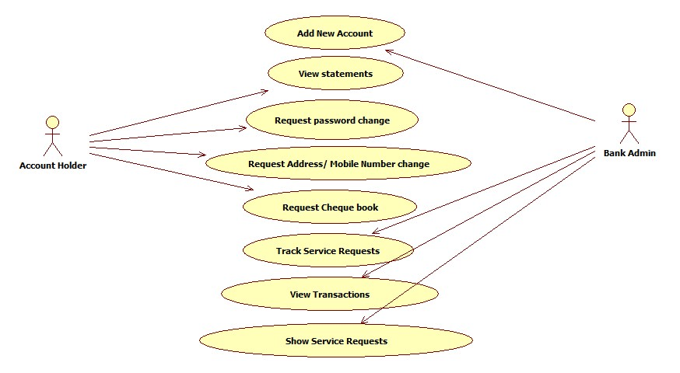

# **10. Scenarios**

Success Scenarios

* Applicant successfully registers in the portal.
* Administrator successfully log in to the portal.
* Administrator successfully adds exam details.

Failure Scenarios

1. All mandatory fields on the Login web page are not given.
2. The User Name field data containing apart from characters
3. The User Name field given with more than 10 characters
4. Passwords with less than six characters.
5. Passwords without having least three of the four available character types: lowercase letters, uppercase letters, numbers, and symbols.
6. Redundant or repeated exam names.
7. The commencement of online registration date is a past date
8. The closure date of an online application is not 30 days from the commencement date
9. The date of the exam is not 60 days ahead of the commencement date
10. The exam description and fees are not mentioned.

# **10. Issues**

1. What if the applicant find same exam name in more than once?
2. What if the applicant wants to apply for an exam in the last date at 00:00:00?
3. What if the applicant session is closed abruptly?
4. Inter System Dependencies

Module: If the User/Administrator enters invalid credentials : Alternate Flow 4.1.2

Impact: The system displays an error message. The system do not navigate to the next page.

User/Admin is retained to step1 of Alternate flow 4.1.2

1. Integration with an already existing System of the <<Administrator>>

Module: Administrator exists in the Employee system

Entity: Employee, Organization, Applications, Administrator

Information: Administrator is an employee of a Banking Exam Portal company. Administrator has an access to the Banking Exam Portal Website.

1. Assumptions
2. Administrator is an employee of company and having access to Intranet.
3. When the applicant stays inactive for 20 minutes in the leave application portal, it automatically expires the session.
4. The administrator has enough permissions to alter the portal like adding an exam etc.

**REVISION HISTORY OF THE WORK PRODUCT**

|  |  |  |  |  |  |
| --- | --- | --- | --- | --- | --- |
| S NO. | Date | Version # | Section Changed | Details of changes made | Approved By |
| 1 |  |  |  |  |  |
| 2 |  |  |  |  |  |